**CSE3020 LAB 10**

**NAME: FARAZ SUHAIL**

**REG. NO.: 19BCE1525**

**Analysis of BikeBuyer Data**

You need to group or classify the given dataset based on the age, yearlyincome, cars and No. of children using R and integrate with tableau to visualize your output.

**OUTPUT**

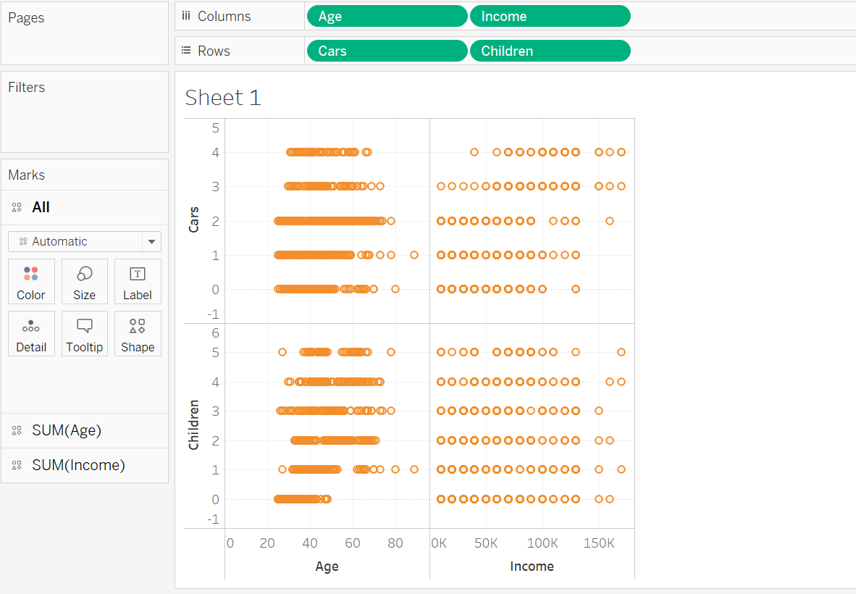

**R**

